***Outside of a dog, a book is man’s best friend. Inside of a dog, it's too dark to read ~ Groucho Marx***

**Contact Information**

Ms. Ayres

Plan: 4th & 8th

[Ms. Ayres SLPS Webpage](https://www.slps.org/domain/12313)

[**Brooke.Ayres@slps.org**](mailto:Brooke.Ayres@slps.org)

**Course Description**

AP English Literature and Composition is an introductory college-level literary analysis course. In this class, you will cultivate your understanding of literature through reading and analyzing texts while exploring concepts like character, setting, structure, perspective, figurative language, and literary analysis in the context of literary works.

**About Me**

I obtained my BA in English in 2011. I went back to school for my certification to teach in 2018. Prior to teaching, I worked in management for fifteen years.

I **LOVE** football (RAVENS!!!!) and hockey (Let’s Go Blues!)

I have two sons, Cole (11) and Dexter (9). Both my sons have Autism, as do I, so ASD awareness is important to me.

In my free time, I love to read, cook, travel, spend time with my family, and watch football.



**Class Expectations**

1. Be prepared to learn.
2. Presume positive intentions.
3. Own your actions.
4. Be your authentic self.

**Class Policies**

**Make-Up / Late Work**

This is an AP course, which means it is a course created to prepare you for college. If you miss a day of school, it is your responsibility to obtain absent work. All printed materials are found at the assignment station. All digital work will be found on your corresponding TEAMS page. You must have work turned in by the end of that unit. Missing work will be marked in the gradebook as an “F”. Any assignments missing by the end of the unitwill **NOT** be accepted. An alternative project **MAY** be available at my discretion at the end of the unit, but it is **NOT** guaranteed.

**Homework**

Research shows homework does not benefit students; therefore, I do not assign it. I will do my best to give you as much class time as possible to complete your work. How you use that time is up to you; **however**, **work not finished in class must be completed and returned by the end of the unit**. Refer to the make-up / late work policy for any questions.

**Plagiarism**

**Do your own work**. Submitting work that is not yours will result in a **zero** as well as a mark of academic dishonesty on your academic record.

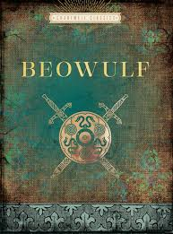**Year at a Glance**

**Unit 1**

Poetry

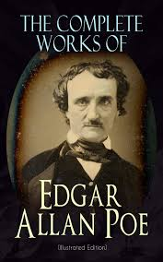Core Text: *Beowulf*

****Unit 2**

Short Fiction

Core Text: The Works of Edgar Allan Poe

**Unit 3**

Longer Fiction / Drama

Core Text: *Heart of Darkness*

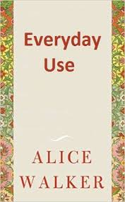

**Unit 4**

Poetry II

Core Text: The Romantic Poets

****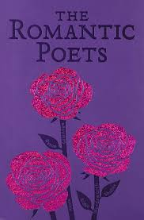

**Unit 5**

Short Fiction II

Core Text: *Everyday Use*

**Unit 6**

Longer Fiction / Drama II

Core Text: *The Watchmen*

*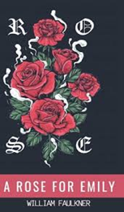***Unit 7**

Poetry III

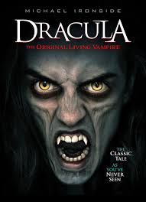Core Text: The Harlem Renaissance



**Unit 8**

Short Fiction III

Core Text: *A Rose for Emily*

**Unit 9**

Longer Fiction / Drama III

Core Text: Dracula

**Grade Breakdown**

Do Now: 10%

Daily Work: 30%

Papers / Projects: 40%

Quizzes: 20%

**RHS Grade Scale**

90-100 A

80-89 B

70-79 C

60-69 D

0-59 F